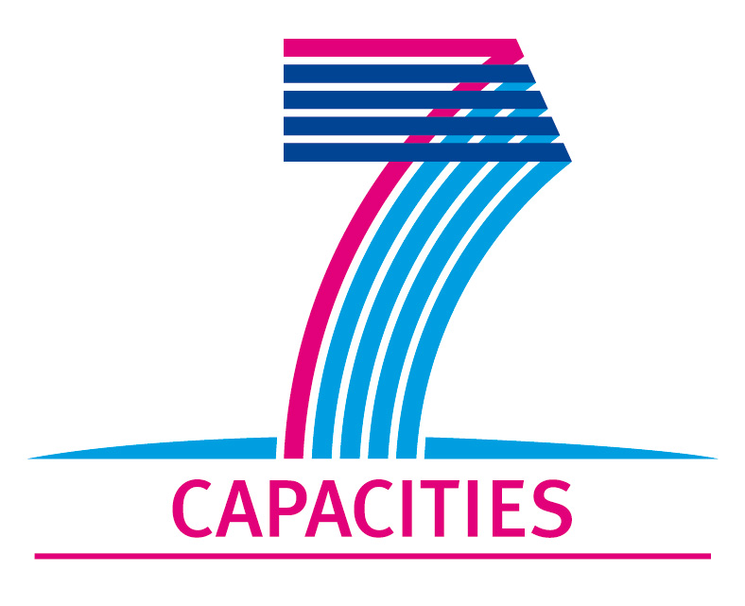 | HP-SEE Dissemination Event Summary Report | 
Title: Scientific-Educational e-Infrastructures in Armenia: Present Status and Perspectives
Place: House of Symposiums of the National Academy of Sciences, Yerevan, Armenia
Date: 12 November 2010
Length of event: 2
Short description:
To prepare a development plan and a vision of scientific-educational e-Infrastructures for Armenia.
URL: http://indico.ipb.ac.rs/conferenceDisplay.py?confId=33
Number of participants: 30
Type of audience:
 | Students
 | Research and University staff
 | Policy makers
 | Industry
 | General public
 | Other

